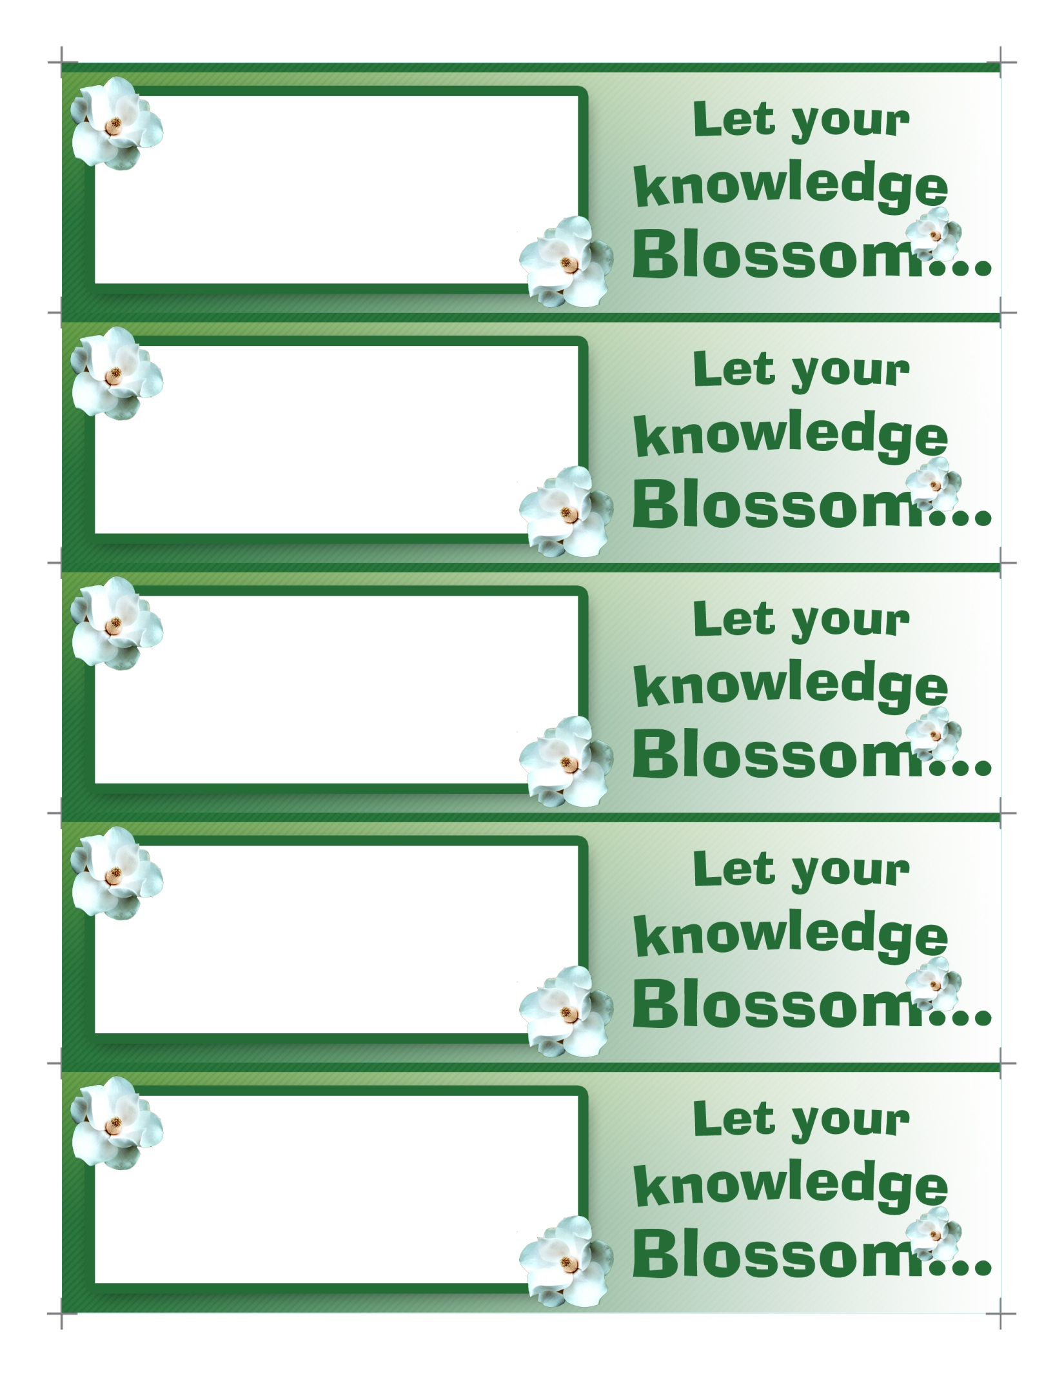

Enter Any

Specific Text Here

Before Printing

Enter Any

Specific Text Here

Before Printing

Enter Any

Specific Text Here

Before Printing

Enter Any

Specific Text Here

Before Printing

Enter Any

Specific Text Here

Before Printing